Castillo, Jimwell

Unit 11 Assignment

Problem 1:

Node.js is a runtime system for creating and integrating server-side applications and at it core it is a highly customizable server engine to help the coder easily build a network or other event-driven application servers. Node.js is related to javascript in a way that it enables Javascript to be used for server-side scripting and runs scripts server-side to produce dynamic web page content before a page is then sent to a user’s web browser.

Problem 2: Node.js Environment Screen Shot

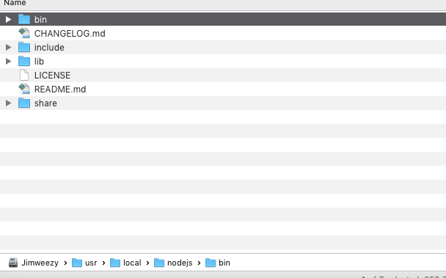

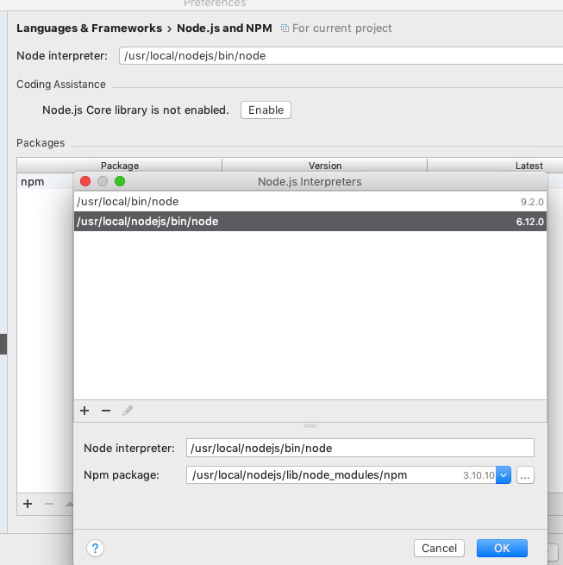/Users/jimweezy/Desktop/Part 2/3.png